Name:A.Reddy Sulochana
Reg.No: 192372370

Exp.No.15 Decision Tree
01.08.26

Aim:
To implement the Decision Tree algorithm using Python for classifying input data based on predefined conditions and predicting the appropriate output through a tree-like decision-making process.
Algorithm:
- Start the program.
- Read the required input values from the user.
- Compare the input values with the predefined decision conditions.
- Check the first decision condition.
- If the condition is satisfied, evaluate the next condition.
- Predict the appropriate class based on the satisfied conditions.
- If the conditions are not satisfied, predict the alternative class.
- Display the predicted decision.
- Stop the program.
Program:
age = int(input("Enter Age: "))
income = input("Enter Income (High/Low): ")
if age > 30:
if income.lower() == "high":
print("Decision: Buy Computer")
else:
print("Decision: Don't Buy Computer")
else:
print("Decision: Don't Buy Computer")age = int(input("Enter Age: "))
income = input("Enter Income (High/Low): ")
if age > 30:
if income.lower() == "high":
print("Decision: Buy Computer")
else:
print("Decision: Don't Buy Computer")
else:
print("Decision: Don't Buy Computer")

Input:
Enter Age: 35
Enter Income (High/Low): High
Output:
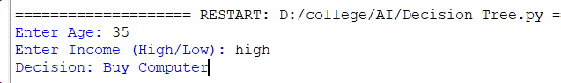

Result:
Thus, the Decision Tree algorithm was implemented successfully using Python. The program classified the given input based on the specified conditions and displayed the correct decision for the entered data.

